Section A  
  
Created script named: internsct1

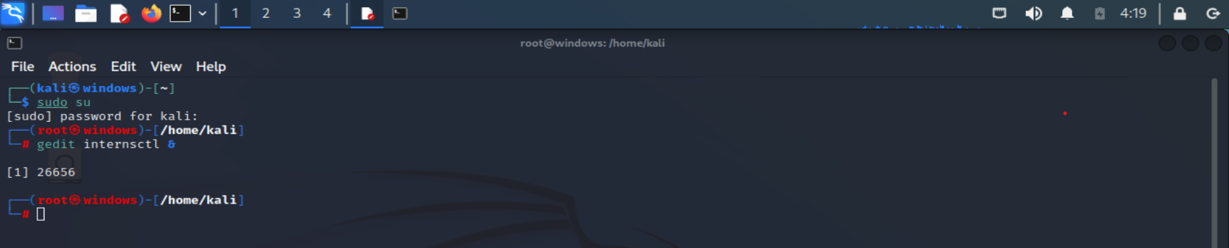

Write code

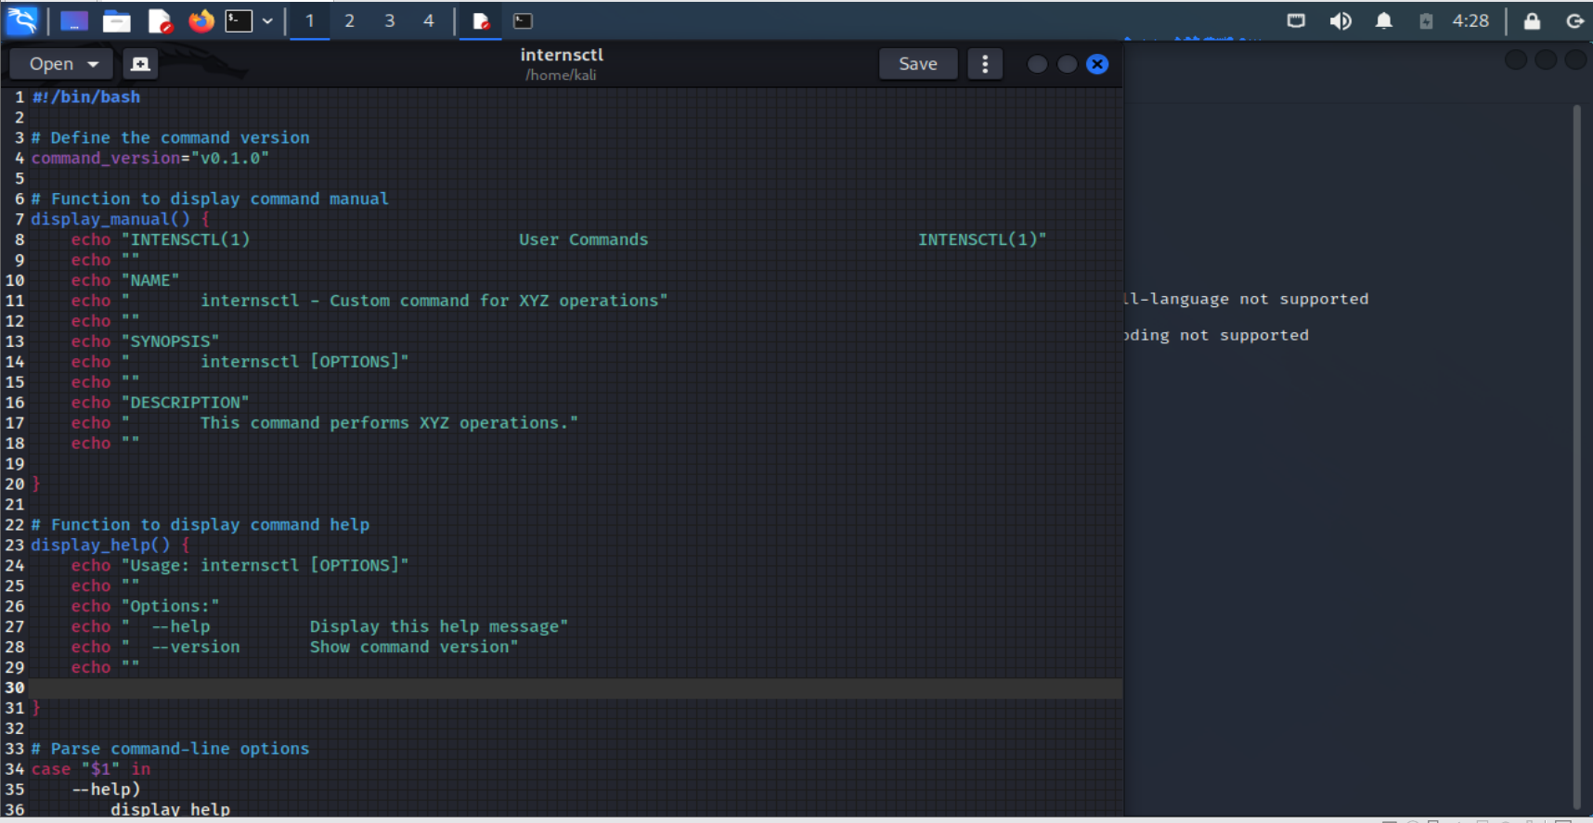

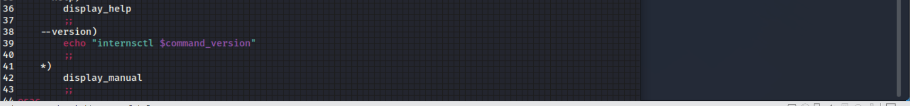

#!/bin/bash

# Define the command version

command_version="v0.1.0"

# Function to display command manual

display_manual() {

echo "INTENSCTL(1) User Commands INTENSCTL(1)"

echo ""

echo "NAME"

echo " internsctl - Custom command for XYZ operations"

echo ""

echo "SYNOPSIS"

echo " internsctl [OPTIONS]"

echo ""

echo "DESCRIPTION"

echo " This command performs XYZ operations."

echo ""

# Add more sections and descriptions as needed for your command

}

# Function to display command help

display_help() {

echo "Usage: internsctl [OPTIONS]"

echo ""

echo "Options:"

echo " --help Display this help message"

echo " --version Show command version"

echo ""

# Add more help information as needed for your command

}

# Parse command-line options

case "$1" in

--help)

display_help

;;

--version)

echo "internsctl $command_version"

;;

*)

display_manual

;;

esac

**Set execution permissions**: Make the script executable using the chmod command:chmod +x internsctl

**Run the script:1.**To view the manual, use man ./internsctl

2. To get help, execute ./internsctl --help.3. To check the version, run ./internsctl --version.

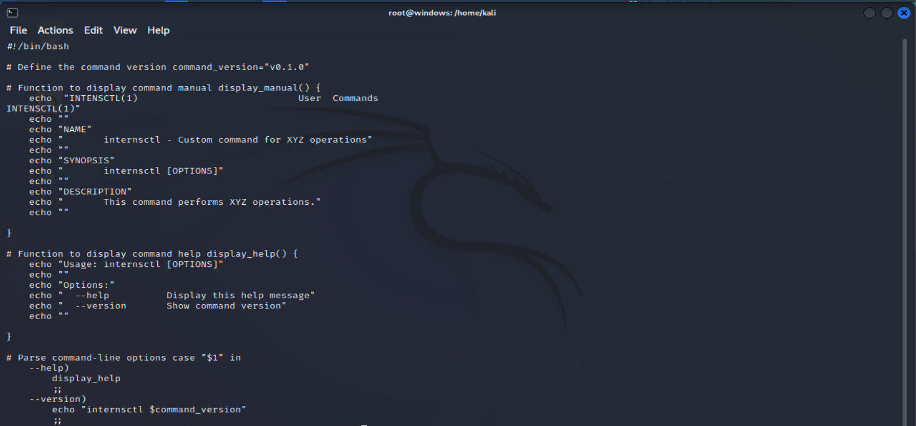



2.  
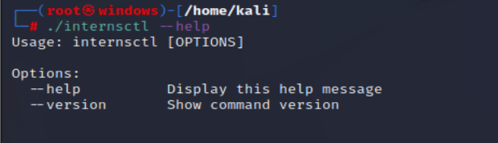

3.

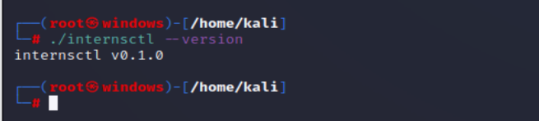

**Section B**

Code:

#!/bin/bash

# Define the command version

command_version="v0.1.0"

# Function to display command manual

display_manual() {

echo "INTENSCTL(1) User Commands INTENSCTL(1)"

echo ""

echo "NAME"

echo " internsctl - Custom command for XYZ operations"

echo ""

echo "SYNOPSIS"

echo " internsctl [OPTIONS]"

echo ""

echo "DESCRIPTION"

echo " This command performs XYZ operations."

echo ""

}

# Function to display command help

display_help() {

echo "Usage: internsctl [OPTIONS]"

echo ""

echo "Options:"

echo " --help Display this help message"

echo " --version Show command version"

echo ""

echo "Part1"

echo " internsctl cpu getinfo Display CPU information (similar to lscpu)"

echo " internsctl memory getinfo Display memory information (similar to free)"

echo ""

echo "Part2"

echo " internsctl user create <username> Create a new user with home directory access"

echo " internsctl user list List all regular users"

echo " internsctl user list --sudo-only List users with sudo permissions"

echo ""

echo "Part3"

echo " internsctl file getinfo <file-name> Get detailed file information"

echo " Options:"

echo " --size, -s Print file size"

echo " --permissions, -p Print file permissions"

echo " --owner, -o Print file owner"

echo " --last-modified, -m Print last modified time"

echo ""

# Add more help information as needed for your command

}

# Function to handle CPU information retrieval

get_cpu_info() {

lscpu

}

# Function to handle memory information retrieval

get_memory_info() {

free

}

# Function to create a new user

create_user() {

if [ "$#" -ne 1 ]; then

echo "Usage: internsctl user create <username>"

exit 1

fi

sudo useradd -m "$1"

}

# Function to list all regular users

list_users() {

cut -d: -f1 /etc/passwd

}

# Function to list users with sudo permissions

list_sudo_users() {

grep -Po '^sudo.+:\K.*$' /etc/group | tr ',' '\n'

}

# Function to get file information

get_file_info() {

if [ "$#" -lt 1 ]; then

echo "Usage: internsctl file getinfo [options] <file-name>"

exit 1

fi

file_name="$1"

shift

file_info=$(stat "$file_name" 2>/dev/null || echo "File not found")

for option in "$@"; do

case $option in

--size|-s)

echo "$file_info" | grep -oP 'Size: \K\d+'

;;

--permissions|-p)

echo "$file_info" | grep -oP 'Access: \K\S+'

;;

--owner|-o)

echo "$file_info" | grep -oP 'Owner: \K\S+'

;;

--last-modified|-m)

echo "$file_info" | grep -oP 'Modify: \K.*'

;;

*)

echo "Invalid option: $option"

;;

esac

done

}

# Parse command-line options

case "$1" in

cpu)

shift

get_cpu_info

;;

memory)

shift

get_memory_info

;;

user)

shift

case "$1" in

create)

shift

create_user "$@"

;;

list)

shift

if [ "$1" = "--sudo-only" ]; then

list_sudo_users

else

list_users

fi

;;

*)

display_help

;;

esac

;;

file)

shift

if [ "$1" = "getinfo" ]; then

shift

get_file_info "$@"

else

display_help

fi

;;

--help)

display_help

;;

--version)

echo "internsctl $command_version"

;;

*)

display_manual

;;

esac

Part A

To get the Cpu information- ./internsctl cpu getinfo

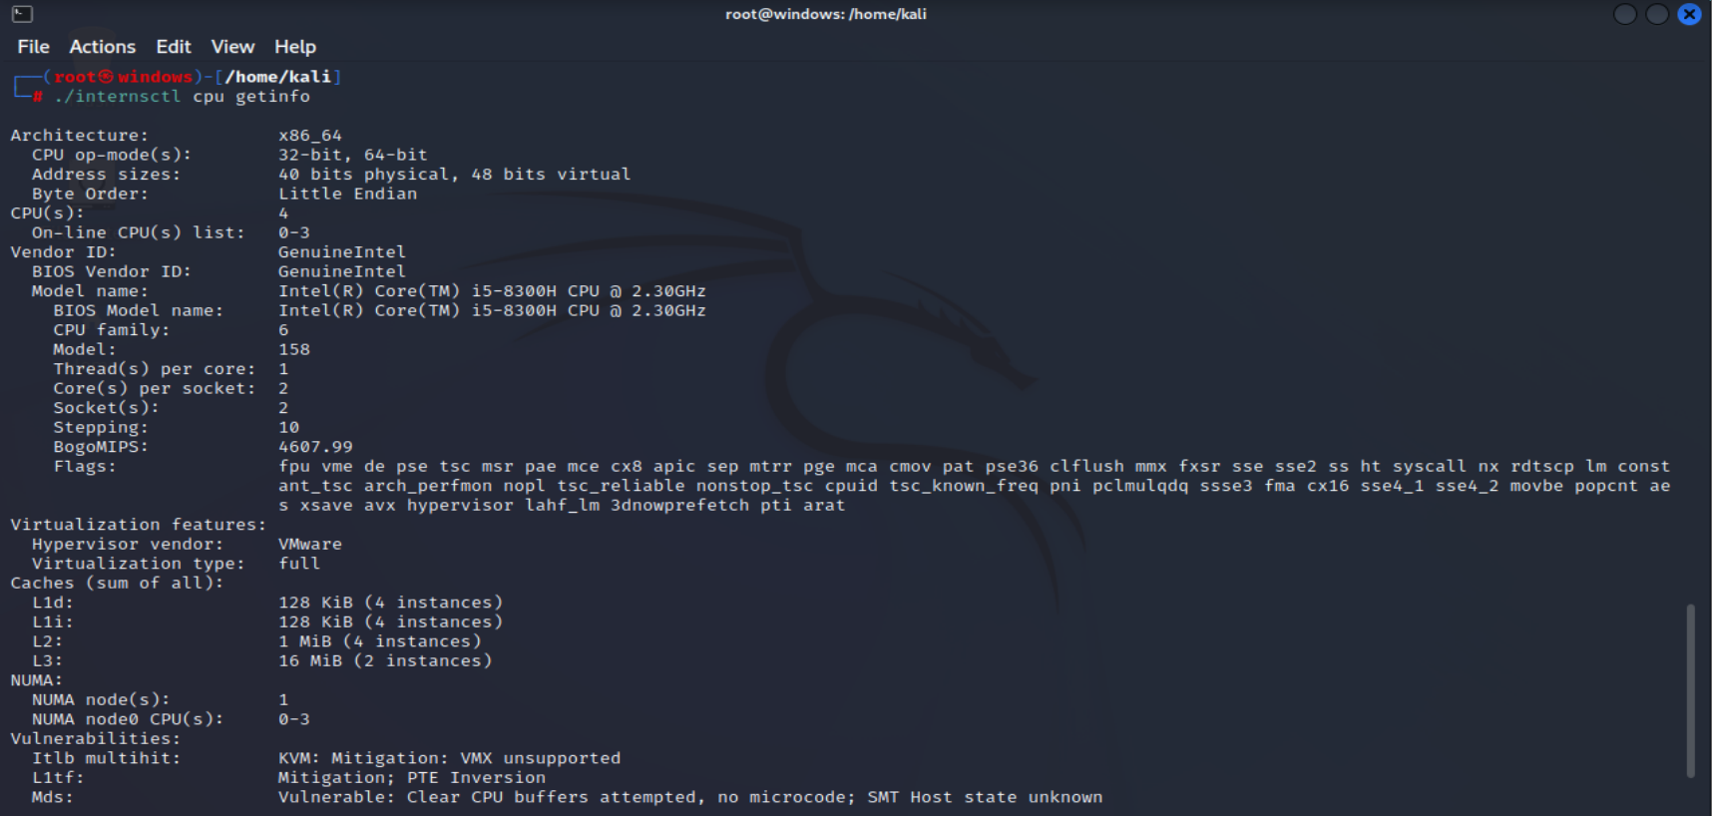

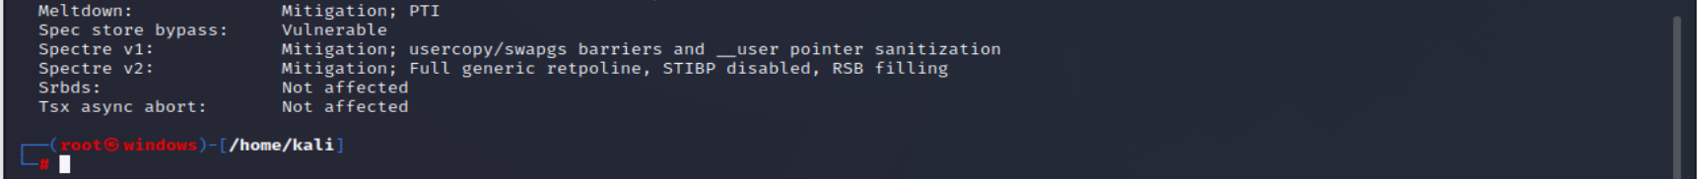

Get memory information - ./internsctl memory getinfo  
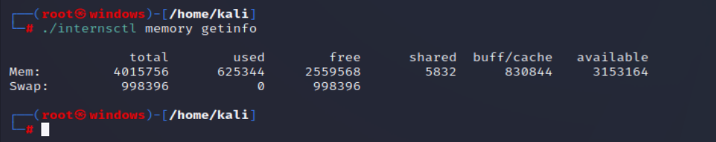  
  
part 2

Create new user - ./internsctl user create admin  
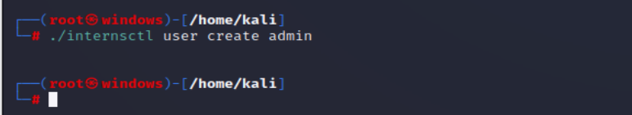

List all regular users - ./internsctl user list  
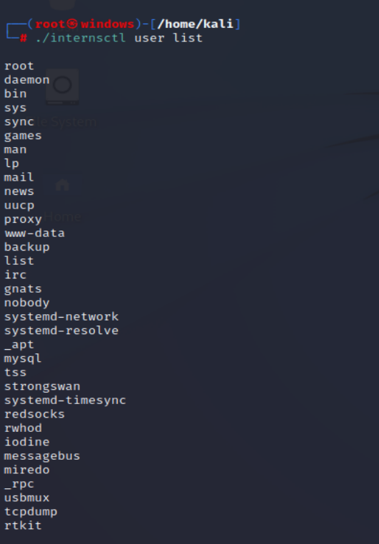

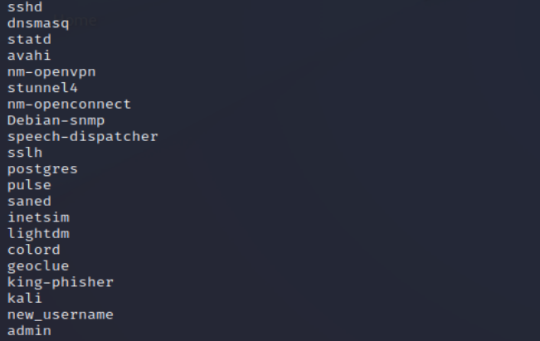

List user with user permission- ./internsctl user list --sudo-only  
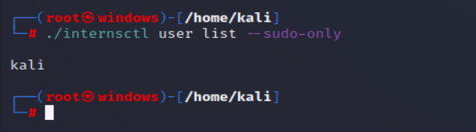

Part 3

Get file information- ./internsctl file getinfo filename  
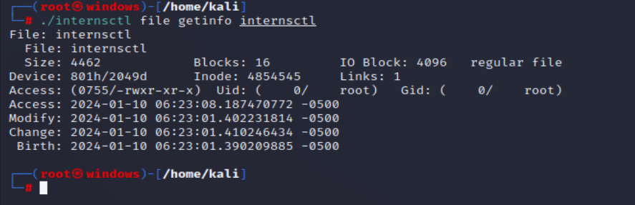

For specific information

